The Paddling Pool

On a hot summer’s day,
There is nothing I like more!
Than to set up the paddling pool,
My mum thinks it’s a chore.

We fill it up early,
So the sun can heat the pool!
Then we jump in,
And all act the fool.

Thomas and Charlie, like to duck and dive,
And Lilyrose likes to jump in.
Emily likes to splash around,
And I like to swim.

Paddling Pools are so much fun,
They help to cool us down.
Especially after a water fight,
When we are hot from running around.

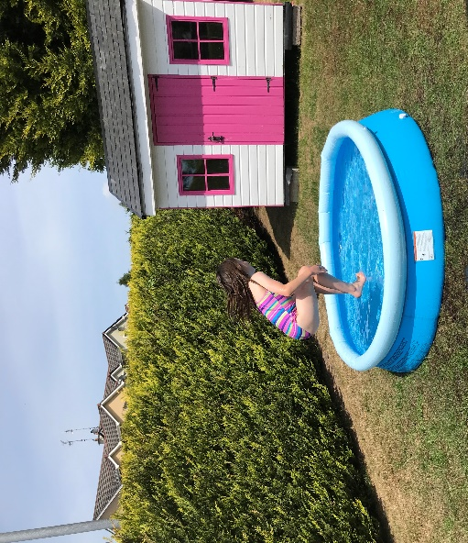
By: Lucy Meenan

